**Overview**

Opening a liquor store have lots of challenges such as location, items, categories. Utilizing the liquor purchases by Iowa Stores will discover insights on these areas and allow business owners to make better decisions that may increase the revenue of their business

**Data**

The dataset used was the liquor purchases by Iowa stores for 2019.

Exploratory data analysis was done to discover insights in the questions below.

**Results**

1a) Which cities have the highest sales?

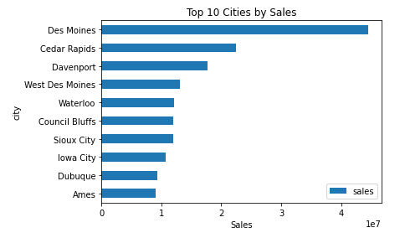

**Figure 1a**: Bar chart of Top 10 Cities by Sales.

In Figure 1a , it shows that the sales for top 3 cities are much higher than the rest of the cities. It will be interesting to explore more why sales in Des Monies are double of Sales in Cedar Rapids and why do these cities are top 10 compared to the rest.

Horizontal bar charts was used as the characters of the cities are long and to reduce the size of bar chart.

1b) Why do these states have high sales than the rest?

In Figure 1b, it shows the top 15 cities population size. The top 3 cities in population are Des Moines, Cedar Rapids and Davenport and it is significantly higher than the rest. It explains why its sales are much higher than the rest as well.

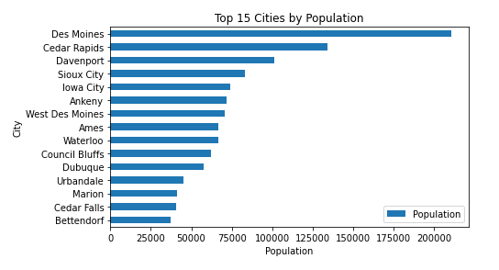

**Figure 1b**: Bar chart of Top 15 Cities by Population.

In Figure 1c, it is a scatterplot between population size and sales in a city. It shows that the population size and sales is moving in the same direction and the points are v close to the linear line. We can conclude that the population size does affect sales

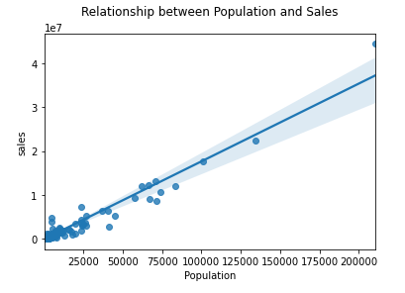

**Figure 1c** : Scatter plot between population size and sales in a city

In Figure 1d, It shows that the top 3 cities by number of stores are Des Moines, Cedar Rapids and Davenport and it is significantly higher than the rest. It explains why its sales are much higher than the rest as well.

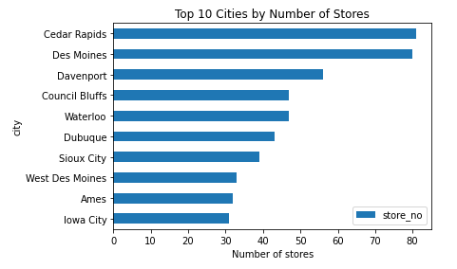

**Figure 1d**: Bar chart of Top 10 Cities by Stores.

In Figure 1e, it is a scatterplot between number of stores and sales in a city. It shows that the number of stores and sales is moving in the same direction and the points are v close to the linear line. We can conclude that the number of stores does affect sales.

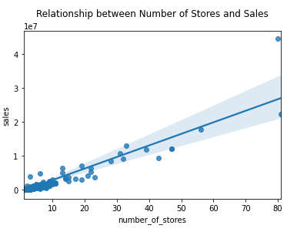

**Figure 1e**: Scatter plot between number of stores and stores in a city

1f) Which cities should a prospective alcohol store choose?

In Figure 1f, it shows the average sales per store in cities. Calculating the average sales per store will be a more accurate representation of the best cities with the best sales instead of taking the top 10 cities by sales.

In Figure 1g, it shows the number of stores by top 15 cities average sales. Mt Vernon, Windsor Heights and Milford have low number of stores yet high average sales. It means that the difference in sales between the stores are not that great.

I recommend Mt Vernon , Windsor Heights and Milford due to its low number of competitors and high average sales per store.

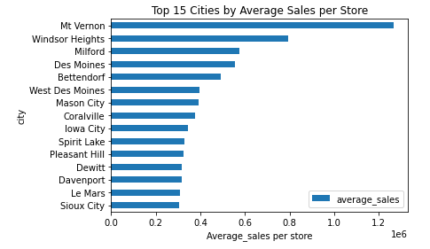

**Figure 1f**: Bar chart of the Top 15 Cities by Average Sales per Store.

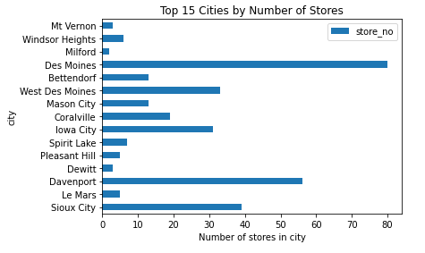

**Figure 1g**: Bar chart of the Top 15 Cities by Average Sales per Store.

2) Which vendors have the highest sales?

In Figure 2 , we can see that the top 10 vendors are established and well known companies. Selecting these vendors will allow the store to earn more revenue.

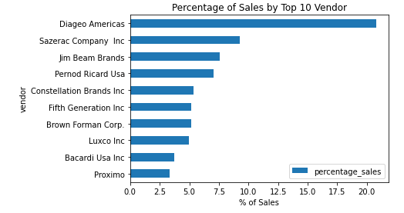

**Figure 2**: Bar chart of Percentage of Sales by Top 10 Vendors.

3) What’s the product distribution based on categories?

In Figure 3a, it shows the percentage of sales by sub-category in a pie chart.

In Figure 3b, we allocate the product distribution according to the pie chart

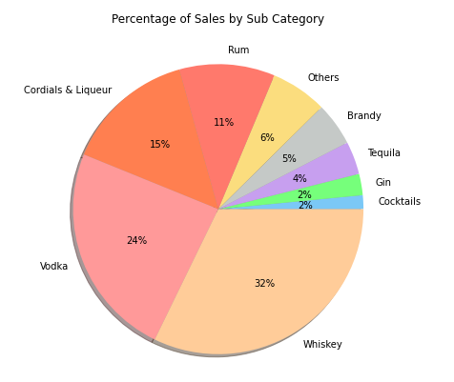

**Figure 3a** : Pie chart of Percentage of Sales by Sub-Category.

|  |  |  |  |  |  |
| --- | --- | --- | --- | --- | --- |
| Percentage of Product Allocation by Sub-Categories | | | | | |
| Liquor Type | Whiskey | Vodka | Cordials & Liqueur | Rum | Others |
| Percentage | 35% | 25% | 15% | 10% | 15% |

**Figure 3b** : Percentage of Products Allocation by Sub-Categories

4) Which bottle volume has the highest sales?

In Figure 4 , it shows the percentage of sales by bottle volume in a bar chart. As the top 3 volume accounts for 85% of the total sales. I recommend that the prospective alcohol owners should sell the alcohol of 750ml , 1000ml and 1750ml

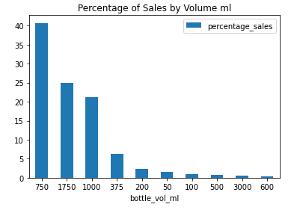

**Figure 4** : Bar chart of Percentage of Sales by Bottle Volume

5) Which items should a prospective alcohol store owner choose?

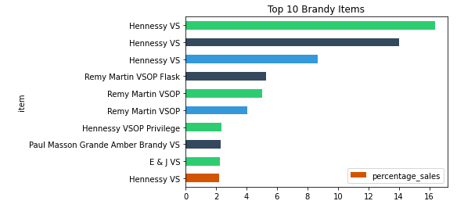

**Figure 5** : Bar chart of Top 10 Brandy items by Percentage of Sales.

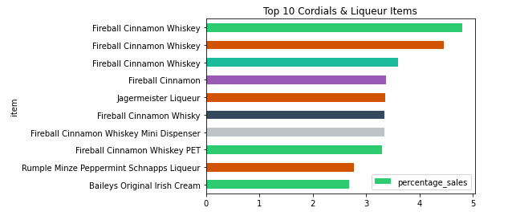

**Figure 6** : Bar chart of Top 10 Cordials & Liqueur items by Percentage of Sales.

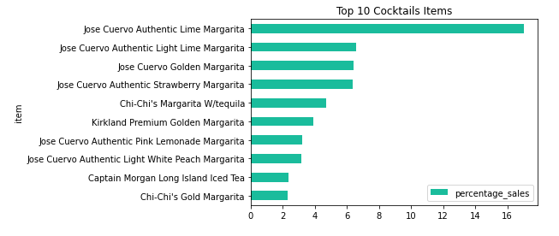

**Figure 7** : Bar chart of Top 10 Cocktail items by Percentage of Sales.

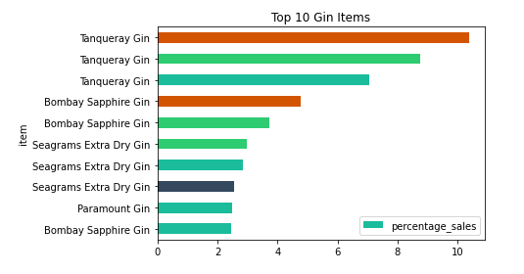

**Figure 8** : Bar chart of Top 10 Gin items by Percentage of Sales.

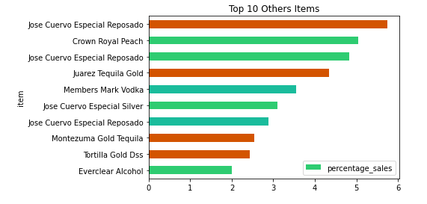

**Figure 9** : Bar chart of Top 10 Other items by Percentage of Sales.

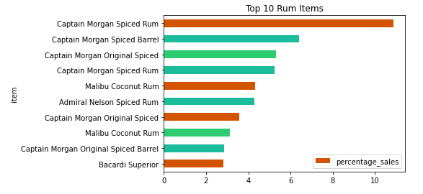

**Figure 10**: Bar chart of Top 10 Rum items by Percentage of Sales.

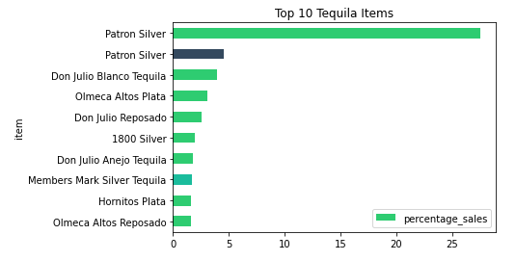

**Figure 11**: Bar chart of Top 10 Tequila items by Percentage of Sales.

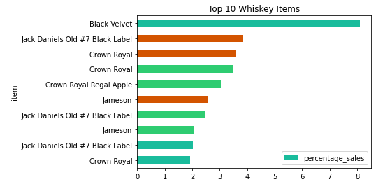

**Figure 12**: Bar chart of Top 10 Whiskey items by Percentage of Sales.

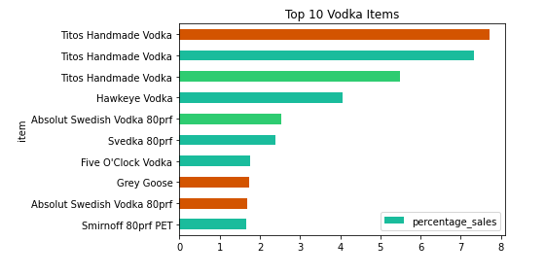

**Figure 13**: Bar chart of Top 10 Vodka items by Percentage of Sales.

**Conclusion (Not completed yet)**

In this exploratory analysis, we observed the following points below ,

Time Series analysis is not applicable to this dataset as not all the days of the year are included in the dataset and the dataset is based on liquor sales purchases by Iowa stores instead of liquor sales by customer as the alcohol purchases may not be sold out in the month

What did u learn from the analysis?